# Admin Page

## Password Validation

### Password Requirement: Min 8 Characters, One Lower case, One upper case and one number

Case 1: Password contains just number >8 characters

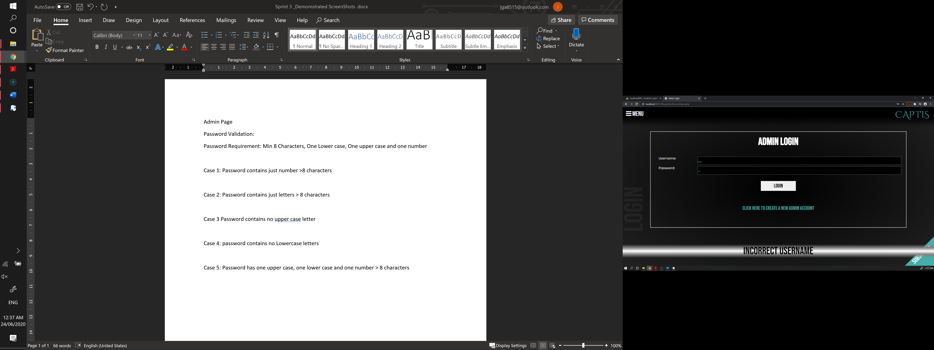

Case 2: Password contains just letters > 8 characters



Case 3 Password contains no upper case letter



Case 4: password contains no Lowercase letters



Case 5: Password has one upper case, one lower case and one number > 8 characters

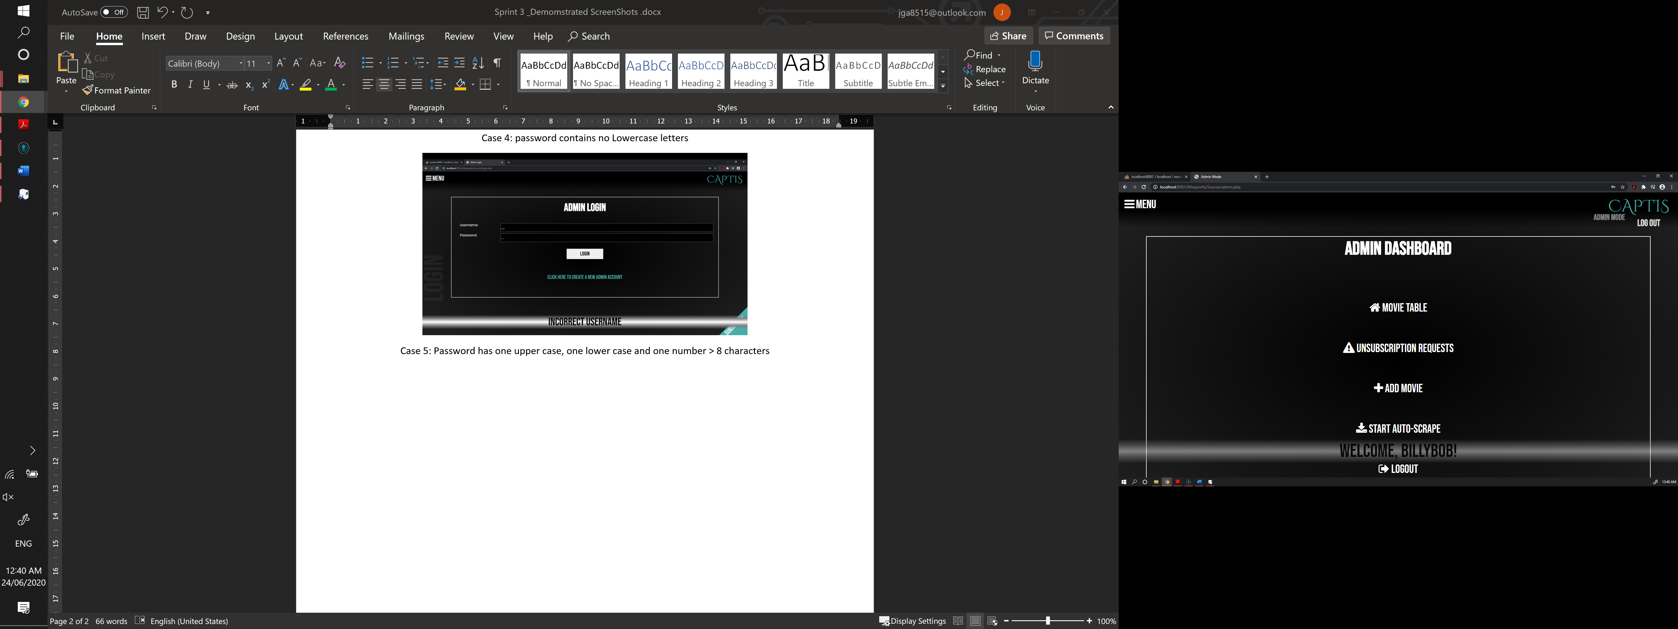

# ANALYTICS AND HISTORY OF ANALYTICS



